Motakamel Plus ERP 2
Motakamel Plus Key Features 3
Motakamel Plus Key Settings 4
Motakamel Plus Administration 5
Motakamel Plus Main Functions Map: 6
Motakamel Plus Help Tools 7
Motakamel Plus Requirements: 8

Motakamel Plus ERP
Integrated accounting and administrative solutions developed on MS SQL Server databases meeting all changes in all different businesses sectors and activities in the financial and human resources management.
It handles many functions of the specialized professions such as Hotels, Restaurants, Projects, Medical Centers, Production Facilities, Documents Archiving, Transportation Management and other specialized requirements in the business market.
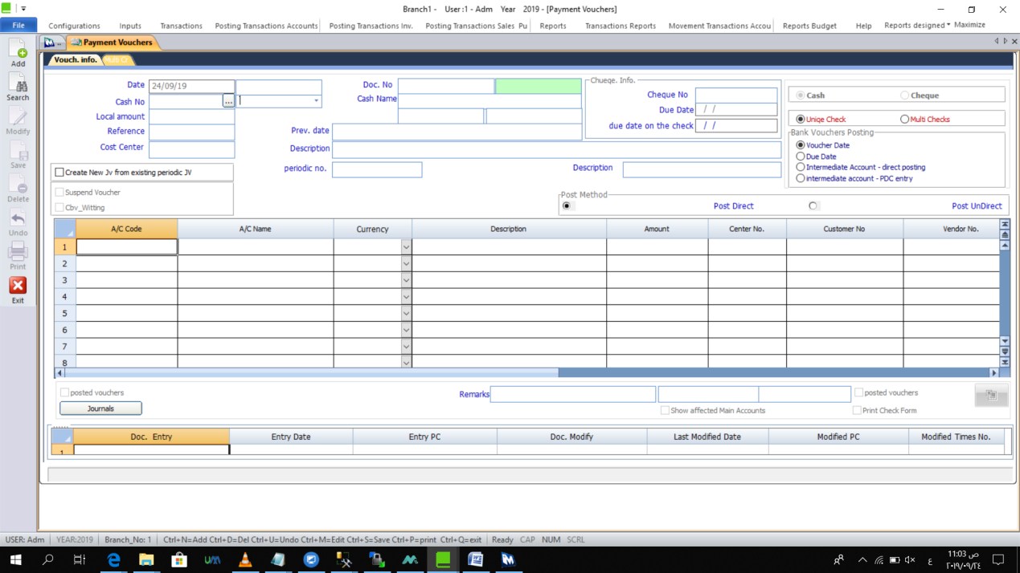
Payment Voucher Screenshot
Why? ‎
- For enterprise organization via solutions that achieve performance accuracy, resources efficiency and better investment.
- For achieving balanced growth during business activities and organizational structure expansion.
- For the flexibility and capability of expansion for achieving strong performance.
- For our clients’ satisfaction and continual success in many countries.
- For flexible configuration, user-friendly, secure data-saving and prompt outcomes.
- For staff expertise in clients service, meeting needs promptly and ongoing software development with new versions.
- For meeting our clients’ needs promptly via out continuous software development.

Motakamel Plus Key Features
- Handle financial, administrative and technical performance in commercial, industrial, and service business enterprises with multiple branches and organizations as in holding companies.
- Highly sufficient work in all business environments, different activities and sectors even those using weights and measurements or having many items such as medicines stores.
- Multilingual: English, Arabic, French and Turkish.
- Developed on MS SQL SERVER database for strong performance, quick processing, data security and flexible integration and linking among modules.
- Meeting activity expansion flexibly and safely, applying the necessary policies in purchases, sales, warehousing, cash, etc.
- Controlling the privileges of the users' functional groups in the activities and branches of the organization and the direct monitoring of the transactions by each user.
- Multiple inventory’s unites for a single item and its display in transactions in a default unit or in a selling/purchasing unit.
- Flexibility of linking the account or item with cost centers in accounting and inventory transactions details or at the level of the whole transaction.
- Handling currencies flexibly in transactions and reports in more than a currency; and controlling currencies at the level of transactions or account.
- Linking items with sub-groups by levels numbers and providing detailed reports accordingly.
- Ability to post temporarily via “save and display records” and final post via “final records approval”, having all detailed reports for all posted/unposted records.
- Shortcuts for prompt reach, such as F5 Items Details, F6 Item Stock Movements, F9 Change Stock Unit and F10 Detailed Account Statement.
- Supporting the administration with immediate reports for risks or opportunities, and comparison reports for more than a branch or organization for the interest of performance and development.
- User-friendly, quick access to several screens and control user theme.

Motakamel Plus Key Settings
- Handling the settings processor for quick and safe configuration according to default data or imported from Excel file.
- Creating the accounting unit and all its related branches, while inputting its main data.
- Identifying the financial period, local currency, stock currency, used currencies, as well as defining the inventory units and interface accounts.
- Creating a main chart of accounts for all branches including their main and sub levels, and defining their approved classifications and groups of accounts.
- Defining cash and bank accounts and determining their related accounts.
- Creating main and sub items groups and linking them with the accounts, and creating items chart and linking it with the related groups and the inventory units.
- Creating detailed charts of accounts for clients, vendors and cost centers, and defining clients and vendors groups accounting to the organization needs.
- Defining sales and collection representatives’ data to be linked with clients, areas and their sales targets.
- Controlling the activation of the inventory’s outgoings in the selling price or transfer/receiving price.
- Selecting the options of dealing with item by assembly and disassembly from available stock as needed and specifying each items’ cost.
- Calculating the Tax to ensure
- Determine the Tax calculation to prove the financial impact in the buying and selling operations according to Items’ multiple taxation, whereas services by sector or Tax type.

Motakamel Plus Administration
- Creating users’ groups, granting users the necessary privileges by groups and controlling these privileges to each single user.
- Management of opening new branches and activities or fiscal years, and inputting its necessary data and related accounting correlations.
- Locking any transactions, accounts or users for certain periods; and closing financial periods monthly or annually with posting balances to a new fiscal year.
- Controlling businesses through displaying transactions movement details by time, user or branch.
- Scheduling automatic backup (daily, weekly, and monthly) through identifying number of copies, backup time, identified hard drive for saving backups with the capability to be restored at any time.
- Selecting the theme, fonts and icons according to the user's needs.

Payment Voucher (Screenshot)

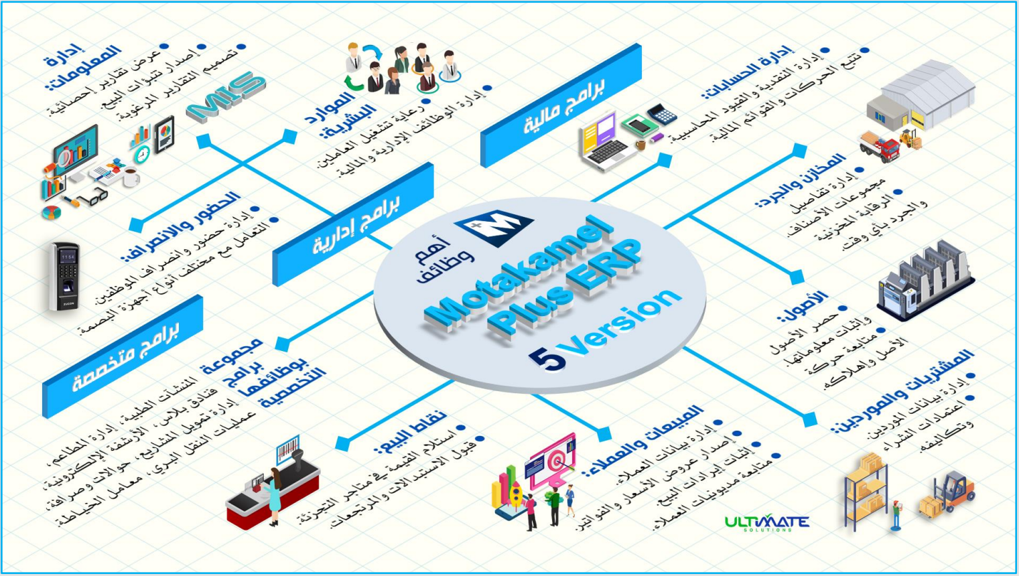
Motakamel Plus Main Functions Map:
Illustrated above the Financial and administrative system that is needed by any commercial business, while specialized systems are of an essential need of their respective functions.
Sales and Clients:
- Managing clients’ data.
- Issuing price quotations and invoices.
- Confirming sales revenues.
- Following up clients debts.
Point of Sales:
- Receiving amount in retail shops.
- Accepting exchanges and returns.
Medical Centers, Restaurants Management, Hotel Plus, Electronic Archiving, Projects Financing Management, Money Transfer and Exchange, Land Transportation and Sewing Labs
Group of Programs with Specialized Functions
Warehouses and Stocktaking:
- Managing items group details.
- Stock control and stocktaking at any time.
Assets:
- Count assets and confirm their info.
- Following up assets and their depreciations.
Purchases and Suppliers:
- Managing suppliers’ data.
- Approving purchase and its costs.
Specialized
Administrative
Financial
Management Information System:
- Display statistical reports.
- Generate sales forecasts.
- Design desired reports styles.
Accounting Management:
- Managing cash and accounting entries.
- Monitoring movements and financial statements.
Human Resources:
- Workforce employment care.
- Manage administrative and financial jobs.
Time Attendance:
- Employees time attendance.
- Supports different types of fingerprint devices.

Motakamel Plus Help Tools
Provide professional and personal work environment for the user. These tools assist the user to carry out his/her tasks via additional technical means and fast procedures via SMS, help and instructions services.
SMS Services:
For sending financial transaction’s notification to clients and suppliers; or accounts balances to the top management to be updated on the organization performance, then an SMS or Email is sent automatically after configuring the necessary information of SMS, Notifications, Sending Options and Recipients. The following are the main advantages:

SMS Advantages:
- Direct access for the transaction notifications by the concerned persons.
- Getting the required information without logging into the system.
- Updating accounts balances after carrying out any transactions.
- Sending explanatory messages or notes individually or collectively.
Help and Instructions:
Part of the user's office work environment to achieve work quality, facilitate quick access to the required tools in the right time and easy access to (Help) information for any screen.

Motakamel Plus Requirements:

Items | System Requirements
Server | - Intel i7 Processor or Intel Xeon with 12GB RAM and 521GB Storage.
 | - Ubuntu 16.04 Operating System,
Terminals | - System is accessible from any terminal.
Reliability And Security | - Developed on MS SQL SERVER database that ensures data security and high accuracy, while featuring automatic secured secondary backup based on the admin preferences.
Languages | - English, Arabic, French and Turkish.
System Installation | - Installed on client's server.
 | - CRM Mobile App is to be installed in client's Smartphone.

After Sales Services
- User uses CRM Mobile App for Technical Support order.
- One Year free subscription to our Online "Remote" technical support.
- Minor subscription fee is imposed after one year.
- Systems are maintained by our team and Hardware is maintained by the client.

